# SQL Task

## Create Table

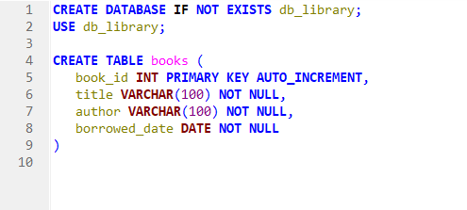

Creates a database named db_library and an empty table named books.

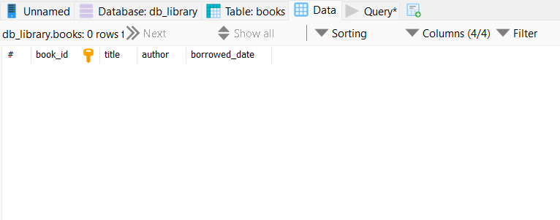

## Data Entry

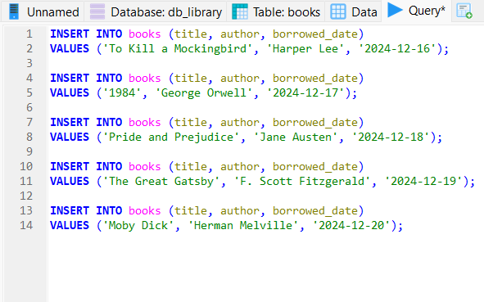

Adds 5 books with author and borrowed date, and date is in YYYY-MM-DD format.

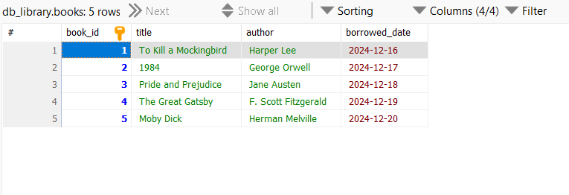

## Basic Queries

### List all books



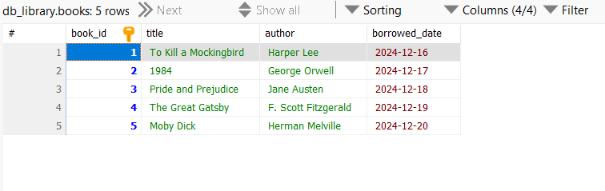

### Find books by author

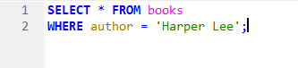

This script find book by Harper Lee.

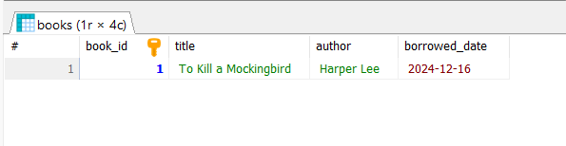

### Find books borrowed on a specific date

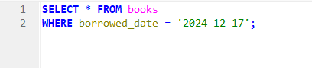

This script finds book borrowed on 2024-12-17

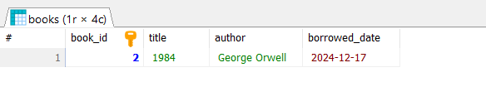

### Find books borrowed after certain date

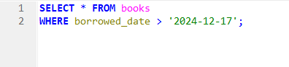

This script finds books borrowed after 2024-12-17

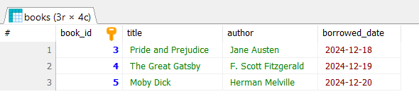

## Data Manipulation

### Update borrowed_date

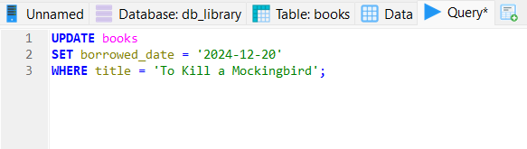

This script change the borrow date from 2024-12-16 to 2024-12-20 for the book ‘To Kill a Mockingbird’

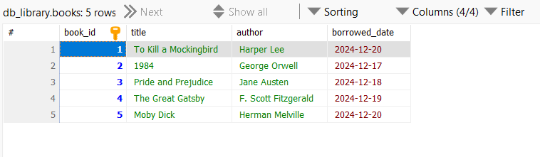

### Delete a book

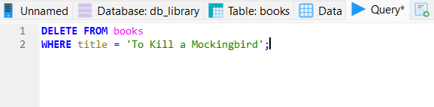

This script deletes book ‘To Kill a Mockingbird’ from the table

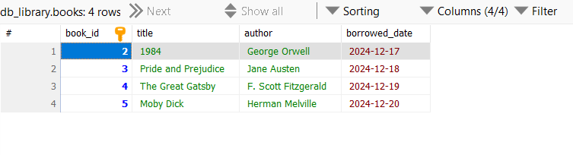

### Re-add book

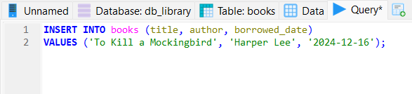

This script adds the ‘To Kill a Mockingbird’ back

